**Solution Offered**

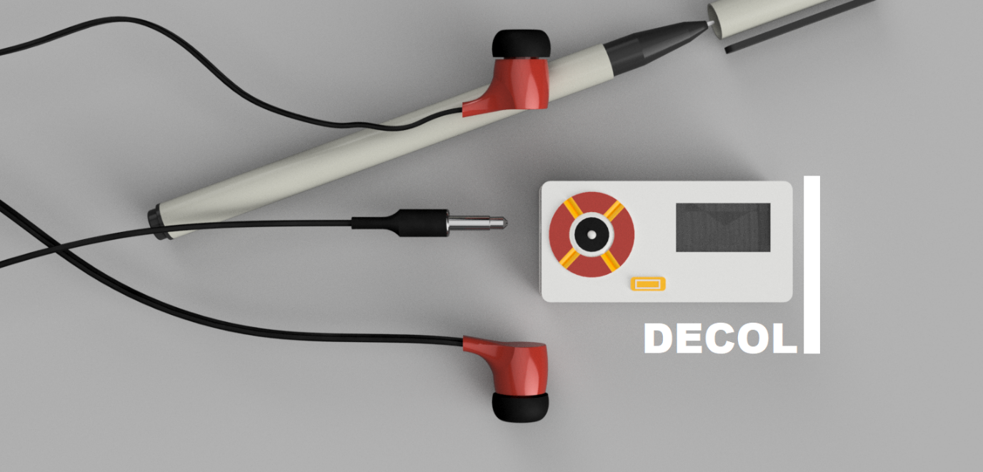

Project Name : **Decoli - DEvice of COgnitive Listening**

Author: Suryasaradhi

*Problem Statement Identified and Current Situation:*

* Designing a headset type portable SDR
* capable of language processing
* Automatic modulation detection and decoding
* Requested Frequency Range : VLF to Ka band : 15khz - 40Ghz
* Long Battery Lifetime

The problem statement is targeted for creating a eavesdropping device , that can be carried on the fly by soldiers, Agents , Military personals etc. Unlike its heavier SDR counterparts which require a separate software end (PC) Decoli doesn’t need another piece of equipment to function, Its all packaged it the small device. The portability guarantees easy use and spot decoding of RF waves transmitted behind enemy lines. The intuitive interface and design significantly reduce the setup time needed for the device to be operable.

Current devices need separate carry bags ,Are bulky, Are power hungry as they need huge Power Adapters, Does not have integration with cutting edge technologies. The innovation Decoli brings forth kicks all these off these problems of the table.

*Proposed Solution:*

See Realtime updates of the project at – **<ENTER GITHUB LINK HERE>**

The proposed solution was a straight forward implementation of the problem statement, Keeping in mind the form factor we reached Stage 1 where we designed the first prototype with tuned down specifications.

Specification Initial prototype:

|  |  |
| --- | --- |
| **Form Factor of Motherboard** | Large [70mm x 35mm x 20mm] |
| **Inter-Connections** | Separated |
| **Technologies Used** | RTL SDR , Raspberry Pi Zero W , Display Module, Battery Management Module |
| **Software Technologies Used** | Python , SDR#, GCP, SVM AI, Data Classification, Universal Radio Hacker (URH platform), GNU Radio |
| **Achieved in Hardware** | * Able to Receive Full RTL SDR Spectrum * Able to Hear audio from radio transmission * Able to Display and navigate the radio platform. * Able to Recharge and reuse battery |
| **Achieved in Software** | * Foundations for GUI of Oled * AI classifier added ,that detects modulation schemes * Playback AM ,FM ,CW Schemes * Translator service calls added |

Figure 1 Simple Stage 1 Architecture

Stage 1 was basically a Raspberry Pi Zero W stacked on a RTL SDR PCB Board , The Pie getting powered from a Battery management IC TP4056 , Using PWM we are getting audio output from the Pie to earphones fed to the user. A wire was extended throughout the length of the earphone wire is used as an antenna.

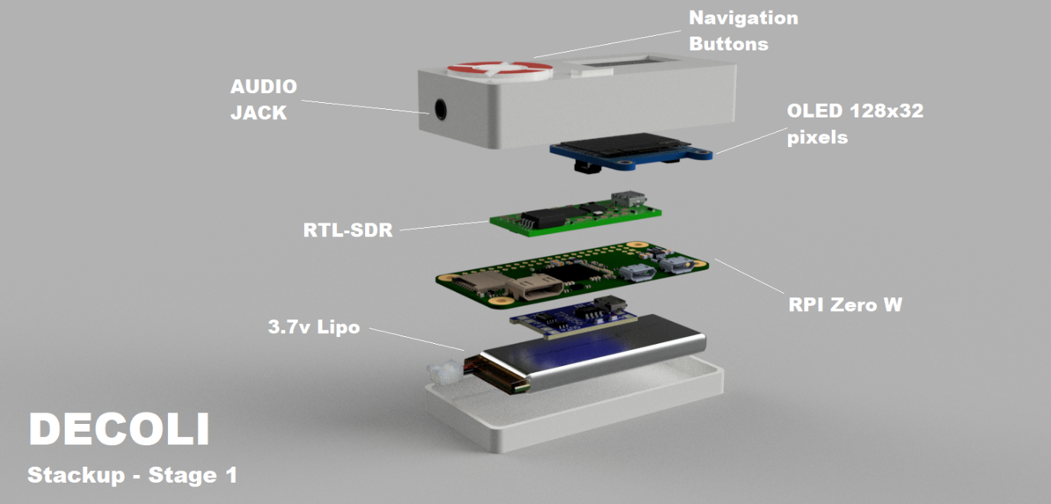

This prototype was the quickest road to a prototype, We took this model as our reference and we based our design with keeping the architecture same, combining everything to a single board. The biggest problem with Stage 1 was it was not production ready, As it used several components that were all separate and **COPYRIGHTED PRODUCTS.** Furthermore the device was now very bulky.

We thus combined all the non copyrighted products into a single 6 layer PCB design, Drastically reducing size. The new product looks different though comes with the same software architecture from our first prototype, thus the code needs simply be forwarded to this prototype. There are major hardware changes as raspberry Pi boards itself is copyrighted we moved onto NUC980 , a Nuvoton Embedded Linux IC. RTL SDR was also copyrighted so we gathered the datasheets of the Tuner and the DSP and created the circuit from scratch, The end circuit is a 3 sheet PCB schematic which was completely built from scratch and assembled to a 6 layer PCB.

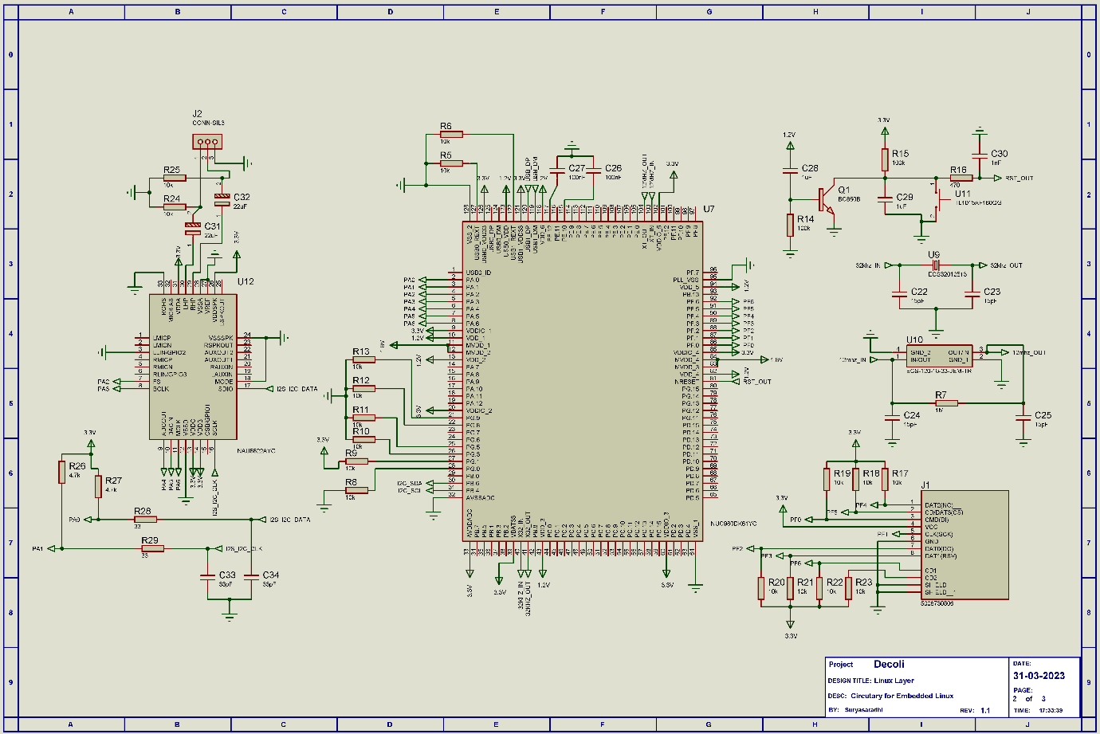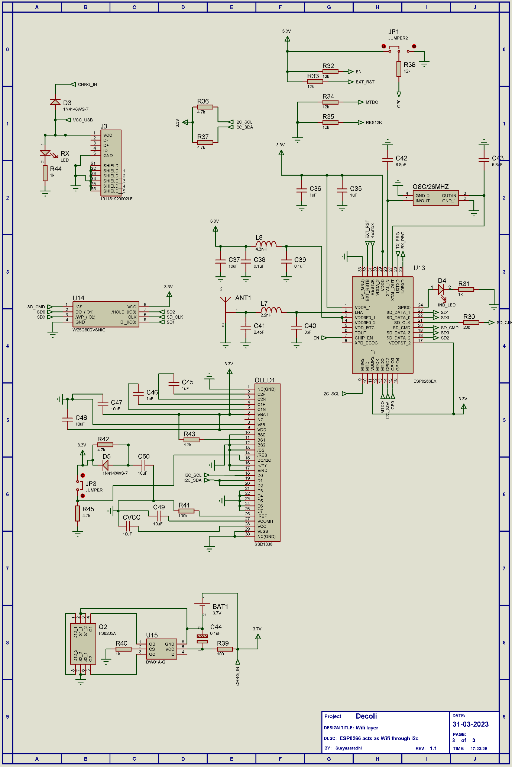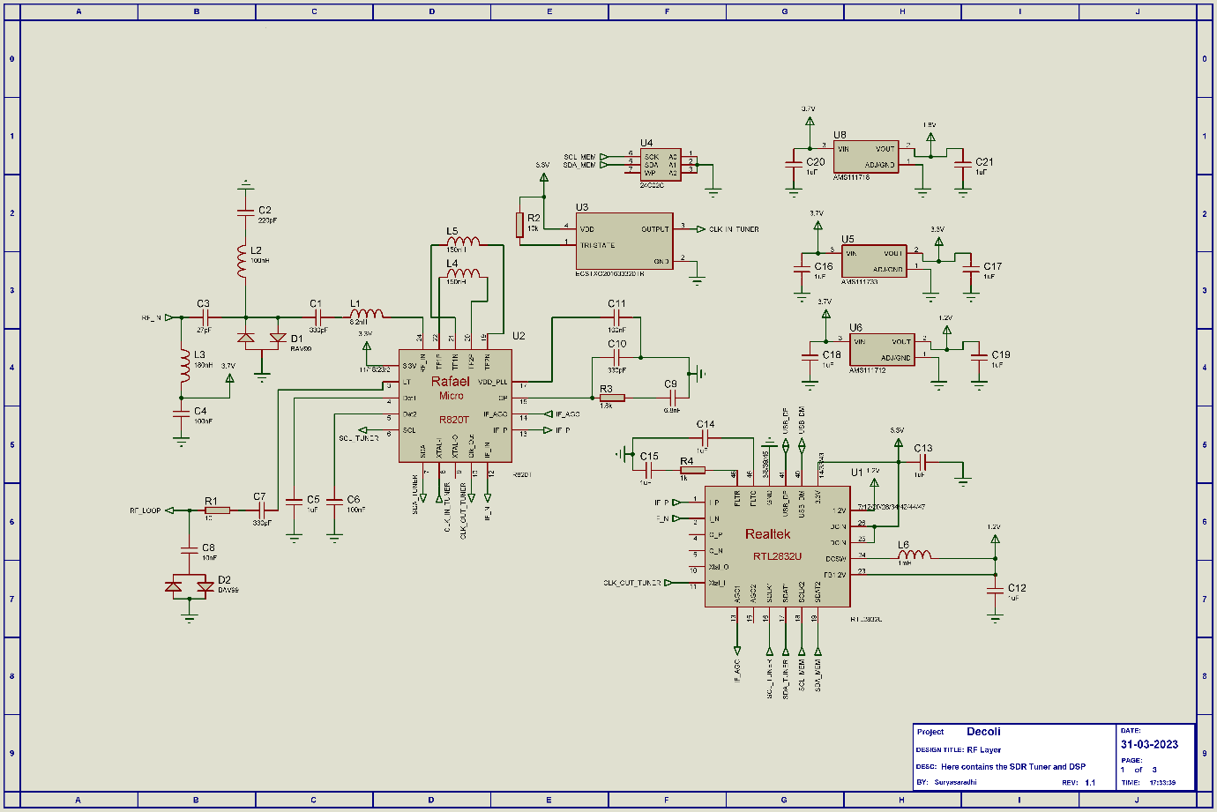

Detailed Specs of the Prototype :

We reduced the form Factor to:

|  |  |
| --- | --- |
| **Form Factor of Motherboard** | Medium [57mm x 27mm x 10mm] |
| **Copyright infringement** | NONE |
| **Inter-Connections** | All On Single board |
| **Hardware Technologies** | * Wi-Fi - 2.5G – Onboard Antenna * HF Direct Sampling Mode * <1 PPM temperature compensated oscillator (TCXO) * Embedded Display and Navigation Controls * Battery Life upto 3 Hours * Oled Display * 3.7V Bias Tee * Switchable Boot Configuration (USB/SD Card) |
| **RF Technologies** | * Full RF Spectrum Sweep * Demod RF Transmissions * Save/Play Transmissions |
| **AI Technologies** | * Detection and Demod of Signals * Translation using GCP |
| **Frequency Sweep** | 500Khz – 1766 MHz **(BW: 3.2Mhz)**  (We have left Space for adding a downconverter for increasing frequency) |

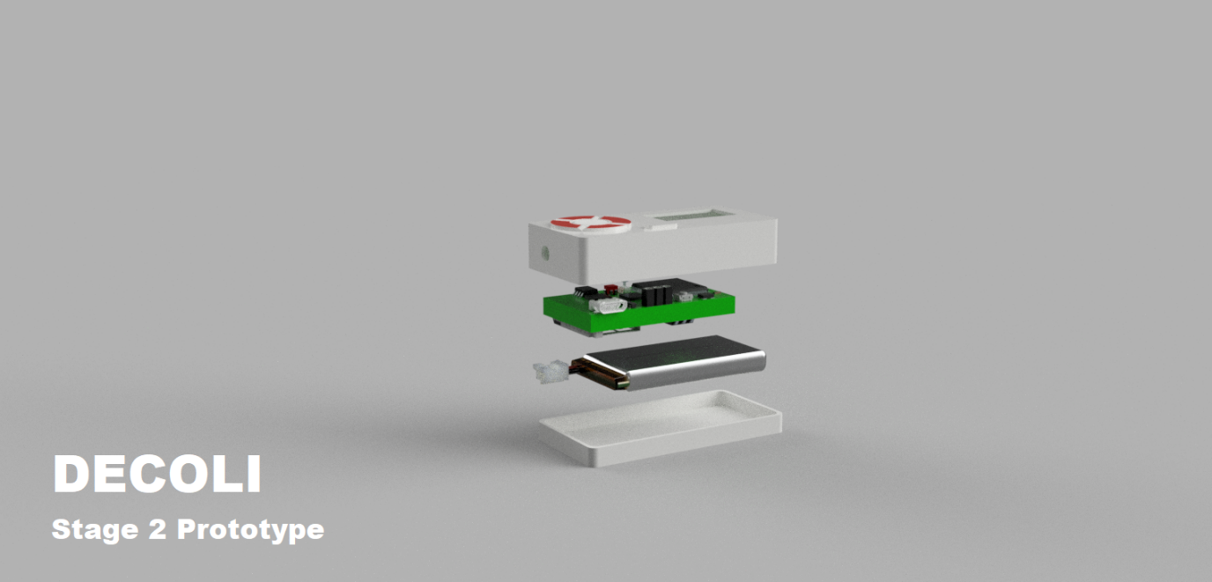

Figure 2 Decoli Stage 2 Prototype ( Condensed PCB)